Programme Name | Aviation Counselling and Guidance programme
Programme Type  (Workshop/ Seminar/ Extension programme etc: | Counselling and Guidance programme
Programme Title | Aviation and Hospitality Excellence
Programme Date | 9th May2026
Programme Duration | 2 Hour
Organized by | AERIS under Career Counselling and Placement Cell
Resource Person | Bimugdha Das Mahanta
No. of Participants | Teachers: 15
No. of Participants | Students: 100
Venue/ Mode | Malay Paul Conference Haul
Programme Outcome: The CCPC (Career Counselling and Placement Cell) Cell of Women’s College, Tinsukia hosted a Counselling and Guidance programme on Aviation on 9th May2026 at the Malay Pal Conference Hall.
The inaugural session of the workshop was chaired by Dr. Mriganka Choudhury, Principal, Women’s College,Tinsukia. He welcomed all the speakers as well as Hon’ble guests & all the participants on behalf of the institution.
A significant Memorandum of Understanding (MoU) was signed between Women’s College, Tinsukia and Bhubans Institute for Leadership and Excellence (BILEx) with the objective of promoting professional education, skill development, and career-oriented training among students. The MoU marked an important step towards strengthening academic and industry collaboration for the benefit of the students.
An introduction of Bimugdha Das Mahanta was delivered by Bhagyalakhi Gogoi, Coordinator of AERIS under CCPC ,Women’s College,Tinsukia. The purpose of the programme was delivered by the Coordinator of AERIS ,Women’s College,Tinsukia covering field on “Aviation ”

The Aviation Counselling and Guidance Programme was successfully organized with the aim of creating awareness among students about the diverse career opportunities available in the aviation sector. The programme was highly informative and interactive, benefiting students who aspire to build their careers in the field of aviation.
The programme was conducted by three distinguished experts from BILEX. The resource persons included Bimugdha Das Mahanta, Centre Director; Moromi Das, Strategic Advisor; and Ranjita Mahanta, Coordinator of BILEX. They explained in a very clear and detailed manner the various career opportunities and prospects available in the aviation industry.
During the session, the experts discussed different fields of aviation such as Pilot Training, Cabin Crew and Air Hostess Services, Airport Ground Staff, Aviation Hospitality, Airport Management, Air Traffic Control and other aviation-related professions. They also highlighted the importance of communication skills, personality development, discipline, confidence, and professional training required for success in this sector.
The speakers guided the students regarding eligibility criteria, admission procedures, training facilities, course duration, placement opportunities, and future career prospects both in India and abroad. They encouraged students to explore aviation as a promising and rapidly growing career field. The interactive counselling session helped students clarify their doubts and gain a better understanding of the aviation industry.
The programme witnessed enthusiastic participation from students and faculty members. Overall, the Aviation Counselling and Guidance Programme was highly successful and proved to be very beneficial, informative, and inspiring for all the participants.
Programme ended with the vote of thanks delivered by Bhagyalakhi Gogoi, Coordinator of AERIS.
.

Evidential Support (Geo-tagged Photos):

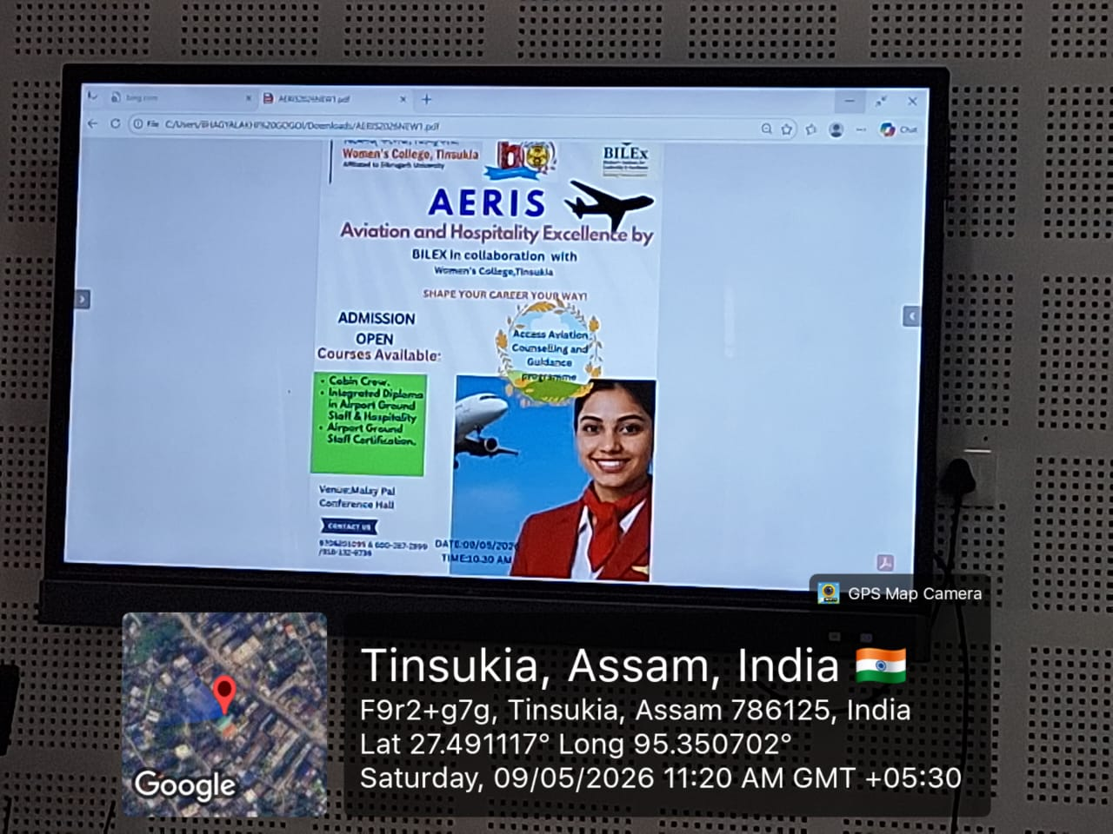

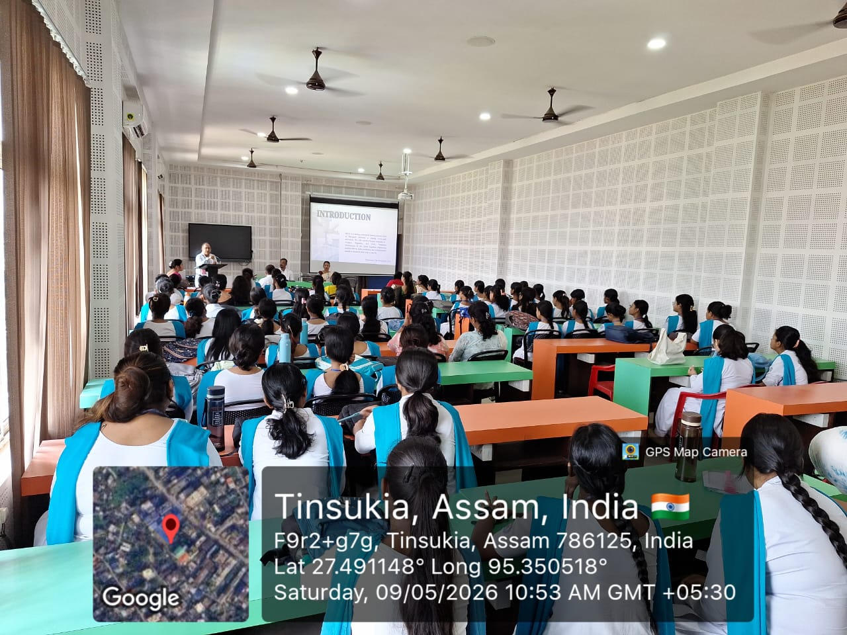

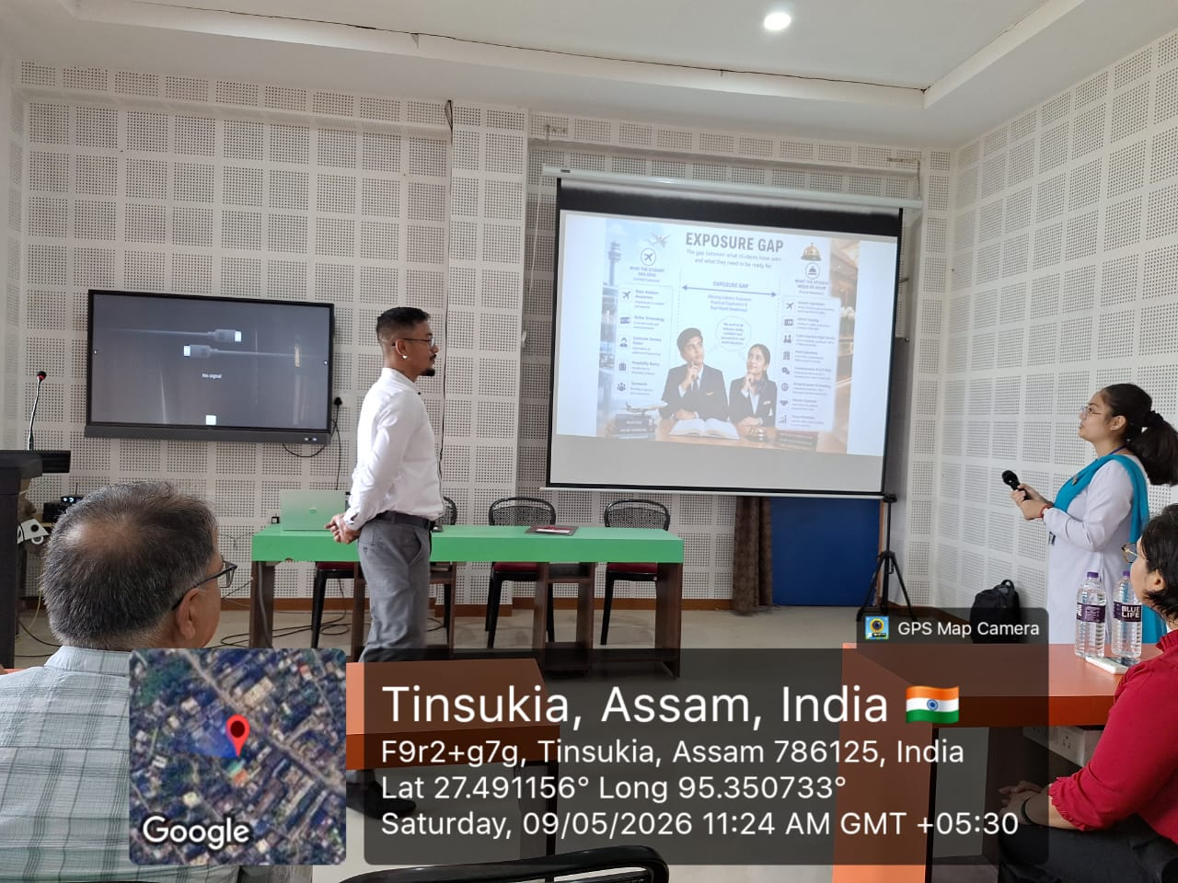

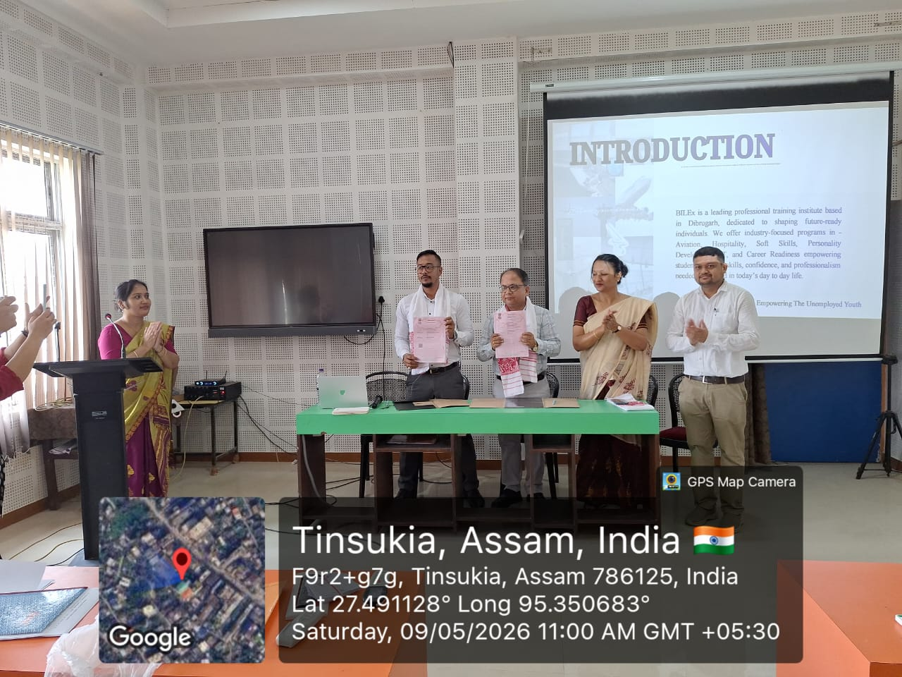

Evidential Support (Photo of E- Certificates, if any) :
Evidential Support (Non Geo-tagged Photos)
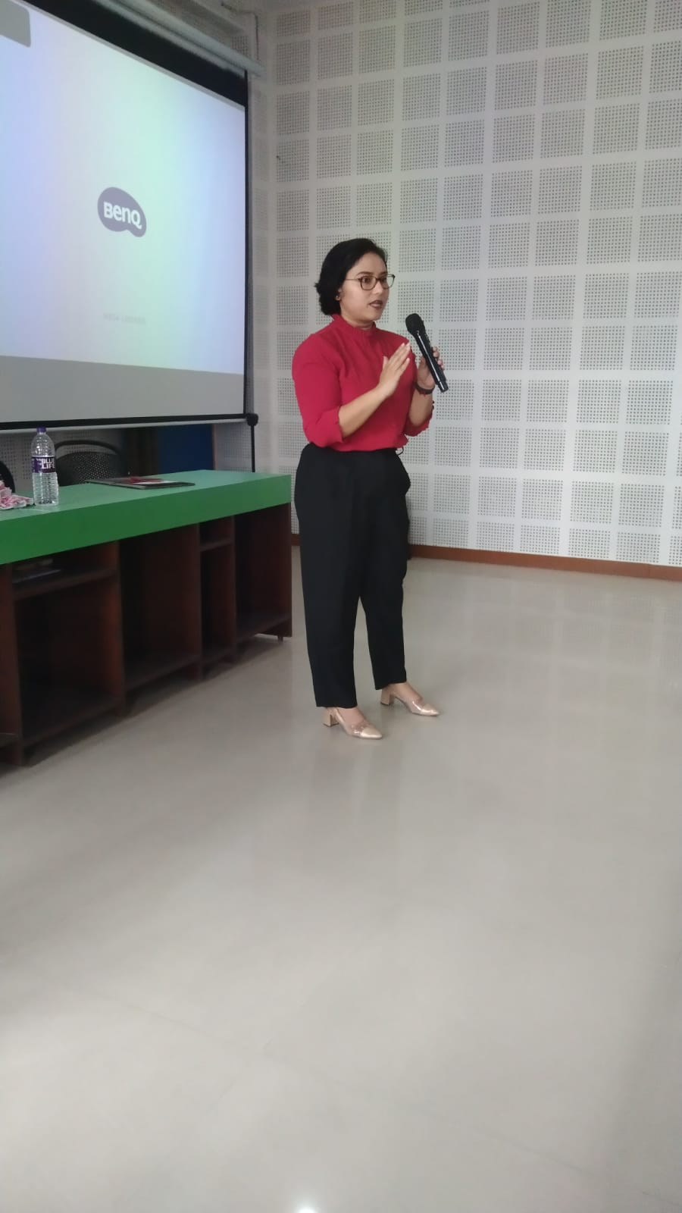

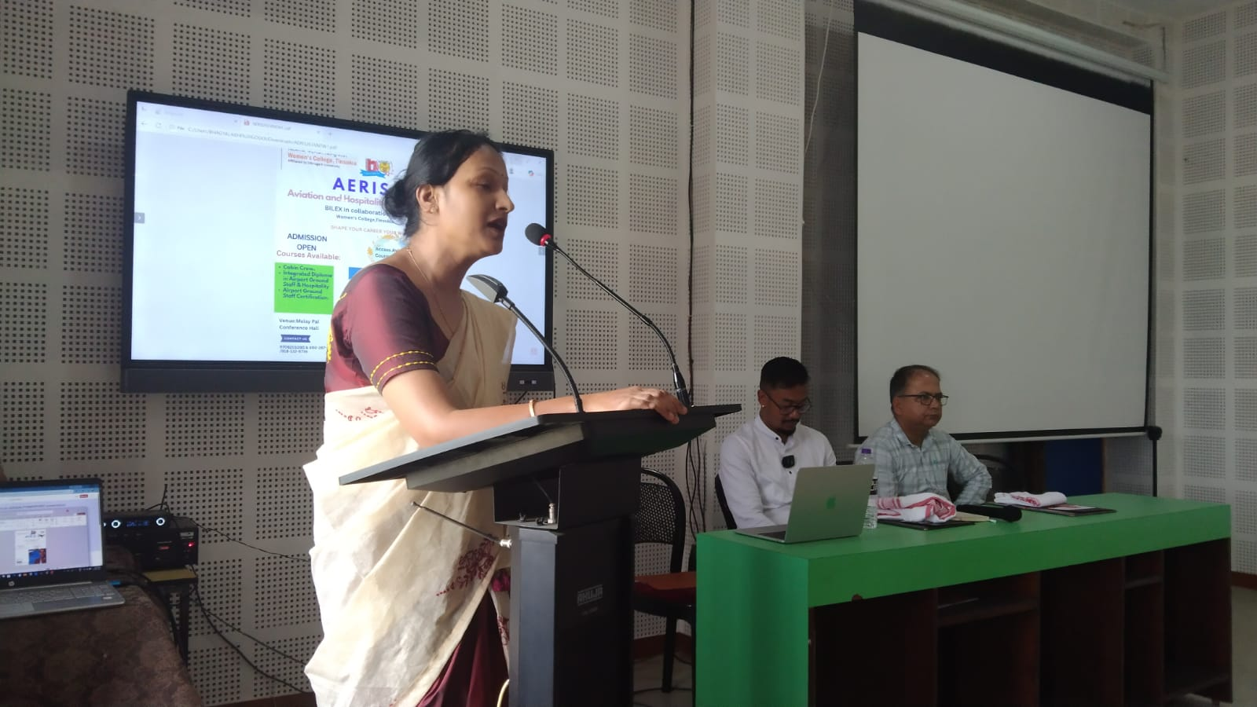

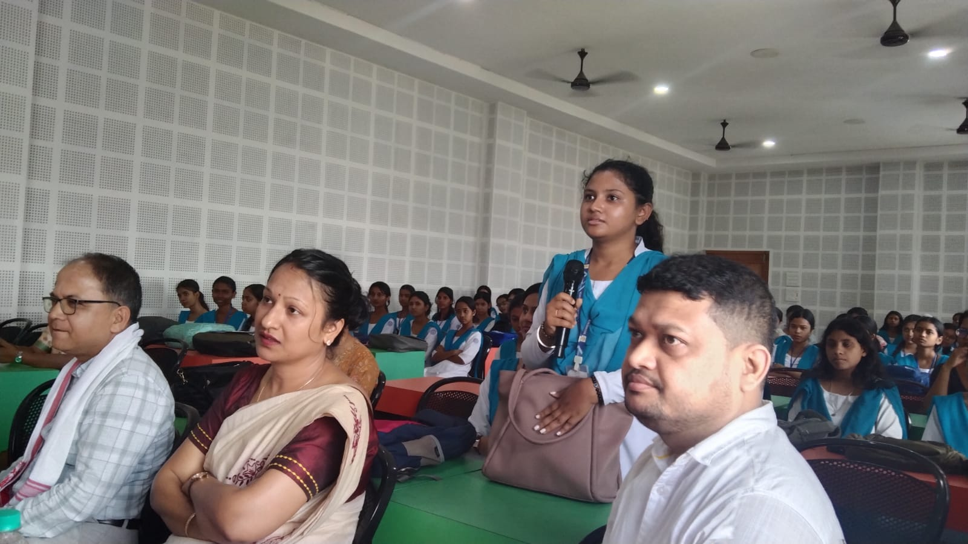


AERIS
Signature of HoD/Convener/ Organiser
(Seal)

